CASE STUDY-23
STUDENT TIMETABLE CONFLICT DETECTION
PROGRAM:
timetable = [
("Python", "Monday", 9, 11, "R101"),
("Java", "Monday", 10, 12, "R102"),
("DBMS", "Tuesday", 9, 11, "R103"),
("Web Development", "Monday", 12, 14, "R101"),
("Computer Networks", "Tuesday", 10, 12, "R103")
]
unavailable_rooms = ["R102", "R105"]
proposed_course = ("AI", "Monday", 10, 12, "R101")
print("=" * 70)
print(" STUDENT TIMETABLE CONFLICT DETECTION")
print("=" * 70)
print("\nExisting Timetable:")
for course in timetable:
name, day, start, end, room = course
print(
f"Course: {name:<18} Day: {day:<10} "
f"Time: {start}:00-{end}:00 Room: {room}"
)
print("\n--- EXISTING TIMETABLE CONFLICTS ---")
conflict_found = False
for i in range(len(timetable)):
for j in range(i + 1, len(timetable)):
course1 = timetable[i]
course2 = timetable[j]
name1, day1, start1, end1, room1 = course1
name2, day2, start2, end2, room2 = course2

if day1 == day2 and start1 < end2 and start2 < end1:
if room1 == room2:
print(
f"Room Conflict: {name1} and {name2} "
f"both use {room1}."
)
conflict_found = True
print(
f"Time Conflict: {name1} and {name2} "
f"overlap on {day1}."
)
conflict_found = True
if not conflict_found:
print("No conflicts found.")
print("\n--- PROPOSED COURSE VALIDATION ---")
name, day, start, end, room = proposed_course
valid = True
if start >= end:
print("Invalid time period.")
valid = False
if room in unavailable_rooms:
print(f"Room {room} is unavailable.")
valid = False
for course in timetable:
old_name, old_day, old_start, old_end, old_room = course
if day == old_day and start < old_end and old_start < end:
print(
f"Time Conflict: {name} overlaps with "
f"{old_name} on {day}."
)
valid = False

if room == old_room:
print(
f"Room Conflict: {room} is already booked "
f"for {old_name}."
)
if valid:
print(f"{name} can be added to the timetable.")
timetable.append(proposed_course)
else:
print(f"{name} cannot be added to the timetable.")
print("\n--- FINAL TIMETABLE STATUS ---")
for course in timetable:
print(course)
print("=" * 70)
OUTPUT: 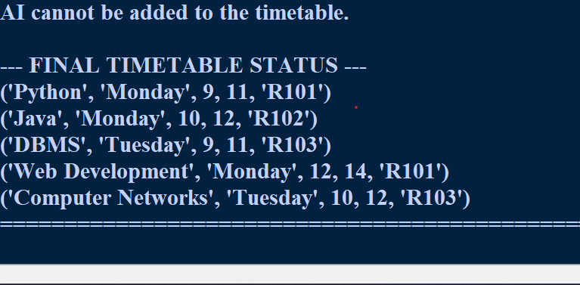 CASE STUDY-23
STUDENT TIMETABLE CONFLICT DETECTION
PROGRAM:
timetable = [
("Python", "Monday", 9, 11, "R101"),
("Java", "Monday", 10, 12, "R102"),
("DBMS", "Tuesday", 9, 11, "R103"),
("Web Development", "Monday", 12, 14, "R101"),
("Computer Networks", "Tuesday", 10, 12, "R103")
]
unavailable_rooms = ["R102", "R105"]
proposed_course = ("AI", "Monday", 10, 12, "R101")
print("=" * 70)
print(" STUDENT TIMETABLE CONFLICT DETECTION")
print("=" * 70)
print("\nExisting Timetable:")
for course in timetable:
name, day, start, end, room = course
print(
f"Course: {name:<18} Day: {day:<10} "
f"Time: {start}:00-{end}:00 Room: {room}"
)
print("\n--- EXISTING TIMETABLE CONFLICTS ---")
conflict_found = False
for i in range(len(timetable)):
for j in range(i + 1, len(timetable)):
course1 = timetable[i]
course2 = timetable[j]
name1, day1, start1, end1, room1 = course1
name2, day2, start2, end2, room2 = course2

if day1 == day2 and start1 < end2 and start2 < end1:
if room1 == room2:
print(
f"Room Conflict: {name1} and {name2} "
f"both use {room1}."
)
conflict_found = True
print(
f"Time Conflict: {name1} and {name2} "
f"overlap on {day1}."
)
conflict_found = True
if not conflict_found:
print("No conflicts found.")
print("\n--- PROPOSED COURSE VALIDATION ---")
name, day, start, end, room = proposed_course
valid = True
if start >= end:
print("Invalid time period.")
valid = False
if room in unavailable_rooms:
print(f"Room {room} is unavailable.")
valid = False
for course in timetable:
old_name, old_day, old_start, old_end, old_room = course
if day == old_day and start < old_end and old_start < end:
print(
f"Time Conflict: {name} overlaps with "
f"{old_name} on {day}."
)
valid = False

if room == old_room:
print(
f"Room Conflict: {room} is already booked "
f"for {old_name}."
)
if valid:
print(f"{name} can be added to the timetable.")
timetable.append(proposed_course)
else:
print(f"{name} cannot be added to the timetable.")
print("\n--- FINAL TIMETABLE STATUS ---")
for course in timetable:
print(course)
print("=" * 70)
OUTPUT: 